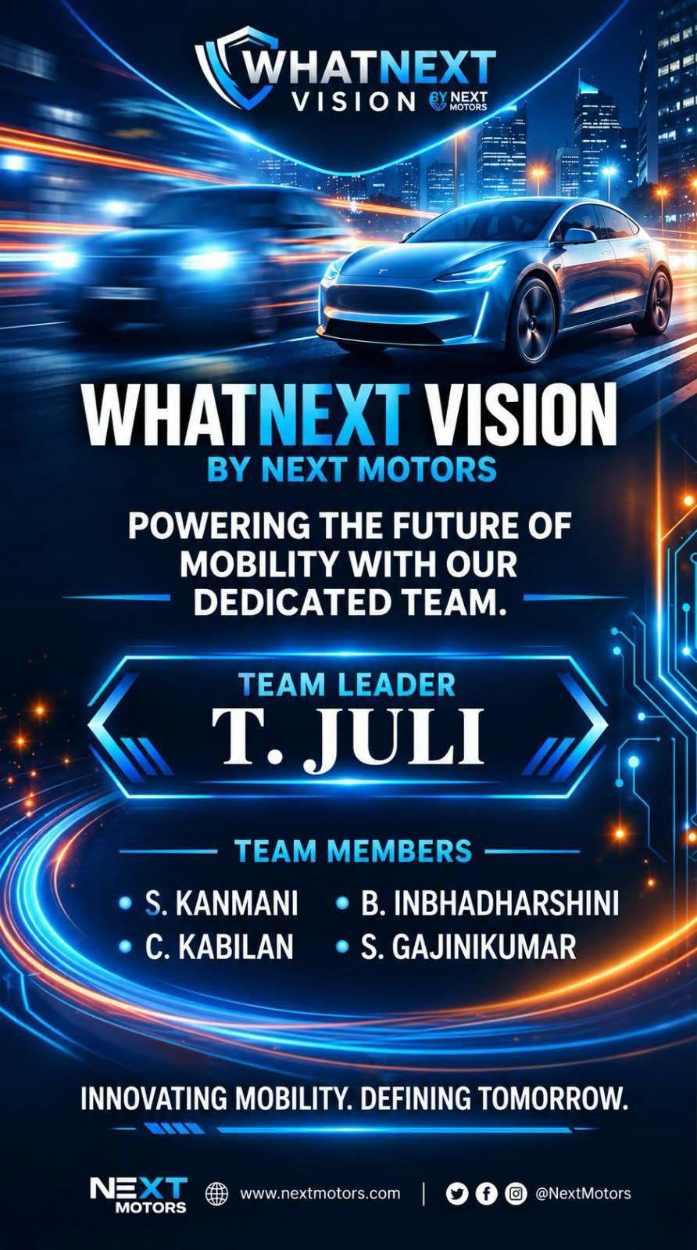

WhatNext Vision Motors:Shipping the
Future of Mobility with Innovation and
Excellence
Use Case:
WhatNext Vision Motors is a pioneering automobile company focused on transforming the mobility sector through innovative technology and customer-centric solutions. The company has undertaken a Salesforce project with the primary objective of improving customer experience, simplifying vehicle ordering, and streamlining its business operations.
At the heart of this project is the automation of the vehicle ordering process. The system is designed to automatically identify and assign the nearest dealer to a customer based on the customer's location. This feature reduces the time required to process orders and ensures that customers are connected with the most convenient dealer.
The project also focuses on vehicle stock availability. Before allowing a customer to place an order, the system checks whether the selected vehicle is available in stock. If the vehicle is unavailable, the system prevents the order from being placed. This helps avoid incorrect orders and improves customer satisfaction.
Furthermore, the system includes an automated process for updating order statuses based on stock availability. If the requested vehicle is out of stock, the order status will be updated to “Pending.” If the vehicle is available, the order status will be updated to “Confirmed.” This provides customers and employees with clear information about the current status of each order.
The Salesforce implementation also supports the management of customers, vehicles, dealers, orders, test drives, and service requests in a centralized system. Automation reduces manual work and allows employees to focus on important customer-related activities.
The implementation of this Salesforce solution is expected to improve operational efficiency, reduce errors, provide faster order processing, and enhance the overall customer experience. By combining Salesforce CRM, automation, Apex, triggers, and batch processing, WhatNext Vision Motors can create a more efficient and technologydriven mobility management system. Requirements:
1. Salesforce CRM Implementation
- Maintain customer, vehicle, dealer, and order information in Salesforce.

- Manage vehicle stock and availability.

- Track customer orders, test drives, and service requests.

- Automatically connect orders with the nearest dealer based on customer location.

- Process Automation

  - Stop customers from creating orders when the selected vehicle is unavailable.

  - Automatically identify and assign the nearest dealer.

  - Update order status according to vehicle stock.

  - Send automatic reminders for scheduled test drives.

- Apex and Trigger

  - Use Apex Triggers to check vehicle availability when an order is created.

  - Automate dealer assignment according to the customer's location.

  - Use Trigger Handlers to keep the Apex code organized and reusable.

  - Apply business rules automatically without manual intervention.

- Batch Jobs

  - Process a large number of order records automatically.

  - Periodically check the stock availability of vehicles.

  - Update order statuses in bulk.

  - Change unavailable orders to “Pending” and available orders to “Confirmed.”

What you’ll learn:
  - Create and manage custom objects, fields, and relationships
  - Manage customers, vehicles, dealers, orders, test drives, and service requests.
  - Check and manage vehicle stock availability.
  - Use Salesforce Flow to automate business processes.
  - Assign an order to the nearest dealer based on customer location.
  - Apex Triggers and Trigger Handlers to implement business rules.
  - Use Batch Apex to process and update large numbers of records.
  - Update order status based on vehicle availability.
  - Create email notifications and reminders for customers.
  - Salesforce automation can reduce manual work and improve customer service.

Mission 1:
Activity 1:Creating Developer Account
  - Creating a developer org in Salesforce. ▪ Go to https://developer.salesforce.com/signup⁠ ▪ On the sign up form, enter the following details:
  - First name & Last name
  - Email
  - Role: Developer
  - Company: College Name
  - Country: India
  - Postal Code: pin code
  - Username: should be a combination of your name and company
Activity 2:Account Activation
  - Go to the inbox of the email that you used while signing up. Click on the Verify Account to activate your account. The email may take 5–10 mins.
  - Click on Verify Account.
  - Give a password and answer a security question and click on Change Password.
  - Then you will redirect to your salesforce setup.

Mission 2:
Activity 1:Create Vehicle Object
The Vehicle object is created in Salesforce to store and manage information about all vehicles available in WhatNext Vision Motors.
Step 1: Open Object Manager
Step 2: Create the Vehicle Object o Click Create. o Select Custom Object.
Enter the following details:
  - Label:Vehicle
  - Plural Label:Vehicles
  - Object Name:Vehicle
  - Record Name:Vehicle Name
  - Data Type:Text ✓ Enable Allow Search.
  - Enable Allow Reports.
  - Enable Allow Activities if required.
  - Under Deployment Status, select Deployed.
  - Click Save.

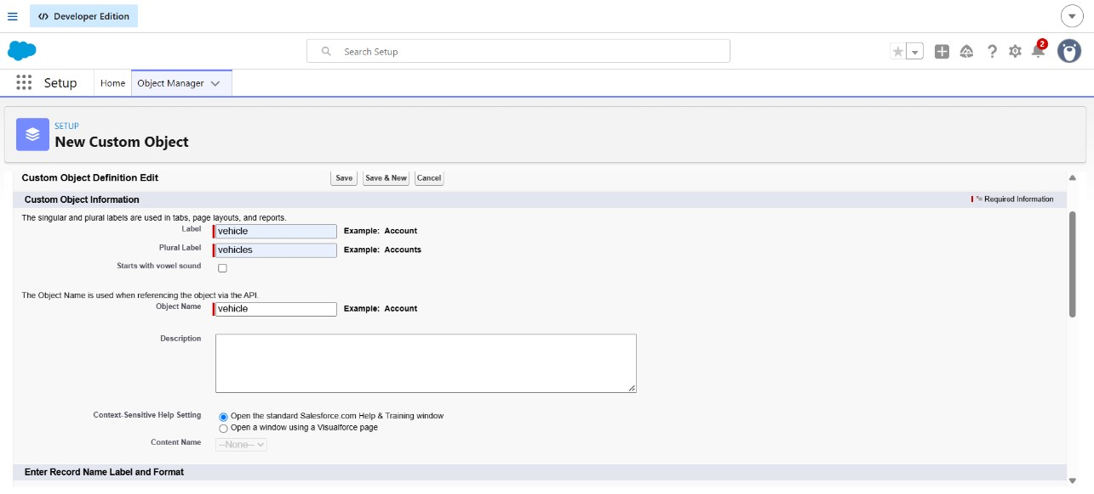

Mission 3:
Activity 1:Creating a Custom Tab
Custom tabs are created in Salesforce to provide easy access to custom objects and their records from the navigation menu. For the WhatNext Vision Motors project, tabs can be created for objects such as Vehicle, Dealer, Customer, Order, Test Drive, and Service Request.
Step 1: Open Setup
  - Log in to your Salesforce Developer Org.
Step 2: Create a Custom Object Tab
  - Under Custom Object Tabs, click New.
  - In Object, select the required custom object.
  - Select a suitable Tab Style.
  - Enter a description if required.
  - Click Next.
  - Select the required Tab Visibility.
  - Set it to Default On if users should see the tab.
  - Click Next.
  - Select the profiles that should have access to the tab.
  - Select the required visibility and permissions.
  - Click Next.
  - Click Save

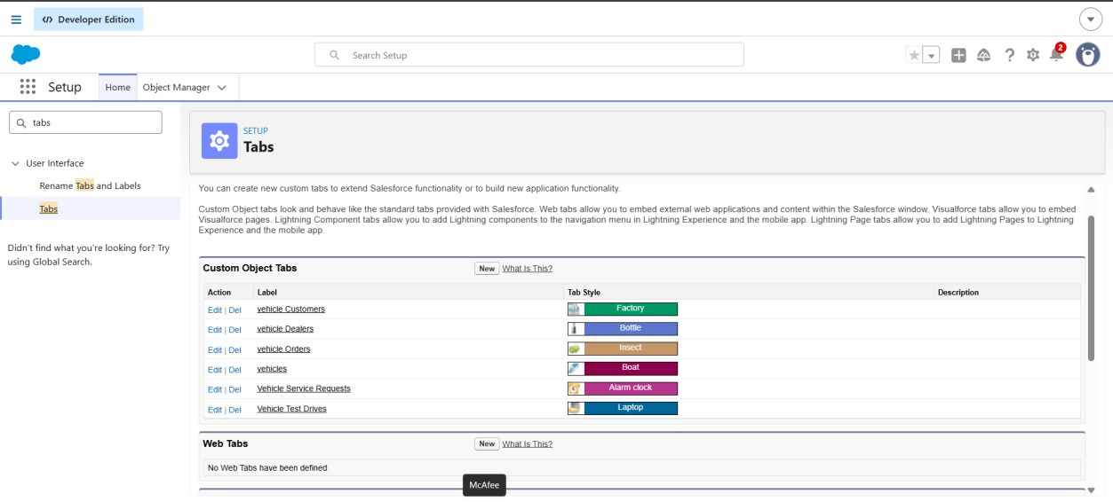

Mission 4:
Activity 1:Creating a Lightning App:
A Lightning App is created in Salesforce to provide users with a single workspace where they can easily access and manage the objects required for the WhatNext Vision Motors project.

- Open App Manager Step 1: Create a New Lightning App ❖ Click New Lightning App.
Enter the following details:
✓ App Name: WhatNext Vision Motors ✓ Developer Name: WhatNext_Vision_Motors ❖ Click Next.
Step 2: Select App Navigation
- Choose Standard Navigation.
- Add the required navigation items.
- Arrange the tabs in the required order. ❖ Click Next.
Step 3: Configure App Options
- Select the required app features.
- Enable Utility Items if required.
- Configure the app according to the project requirements. ❖ Click Next.
Step 4: Assign User Profiles
- Select the profiles that should have access to the application.
- For a developer project, select the required user profile.
- Click Save & Finish.

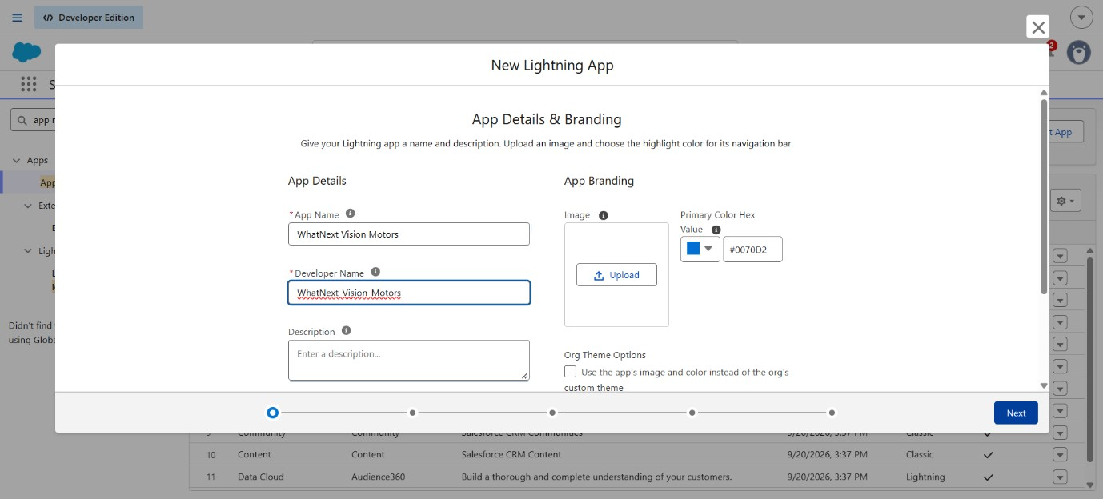

Mission 5:
Fields and Relationship
- Vehicle__c (Custom Object)
  - Vehicle Name (Text)
  - Vehicle_Model__c (Picklist: Sedan, SUV, EV, etc.)
  - Stock_Quantity__c (Number)
  - Price__c (Currency)
  - Dealer__c (Lookup to Dealer__c)
  - Status__c (Picklist: Available, Out of Stock, Discontinued)
- Vehicle_Dealer__c (Custom Object)
  - Dealer_Name__c (Text)
  - Dealer_Location__c (Text)
  - Dealer_Code__c (Auto Number)
  - Phone__c (Phone)
  - Email__c (Email)
- Vehicle_Order__c (Custom Object)
  - Vehicle_Customer__c (Lookup to Vehicle_Customer__c)
  - Vehicle__c (Lookup to Vehicle__c)
  - Order_Date__c (Date)
  - Status__c (Picklist: Pending, Confirmed, Delivered, Canceled)
- Vehicle_Customer__c (Custom Object)
  - Customer_Name__c (Text)
  - Email__c (Email)
  - Phone__c (Phone)
  - Address__c (Text)
  - Preferred_Vehicle_Type__c (Picklist: Sedan, SUV, EV, etc.)
- Vehicle_Test_Drive__c (Custom Object)
  - Vehicle_Customer__c (Lookup to Vehicle_Customer__c)
  - Vehicle__c (Lookup to Vehicle__c)
  - Test_Drive_Date__c (Date)
  - Status__c (Picklist: Scheduled, Completed, Canceled)
- Vehicle_Service_Request__c (Custom Object)
  - Vehicle_Customer__c (Lookup to Vehicle_Customer__c)
  - Vehicle__c (Lookup to Vehicle__c)
  - Service_Date__c (Date)
  - Issue_Description__c (Text)
  - Status__c (Picklist: Requested, In Progress, Completed)

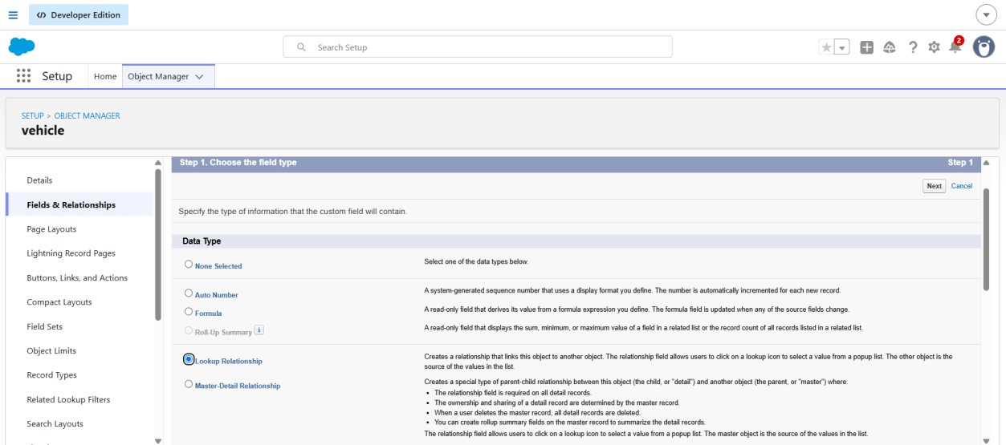

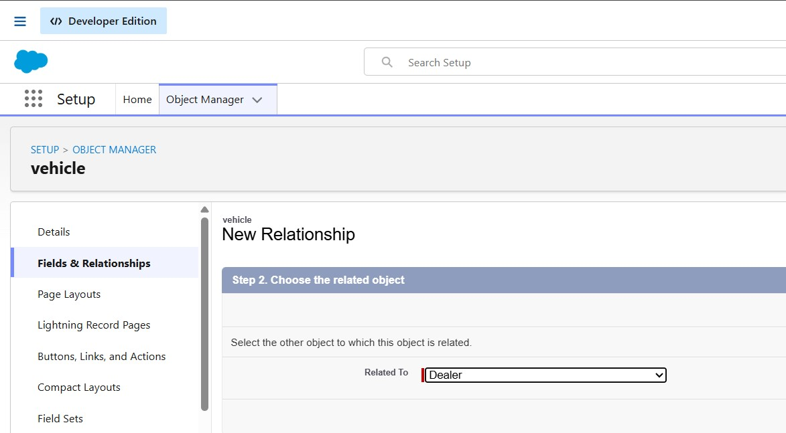

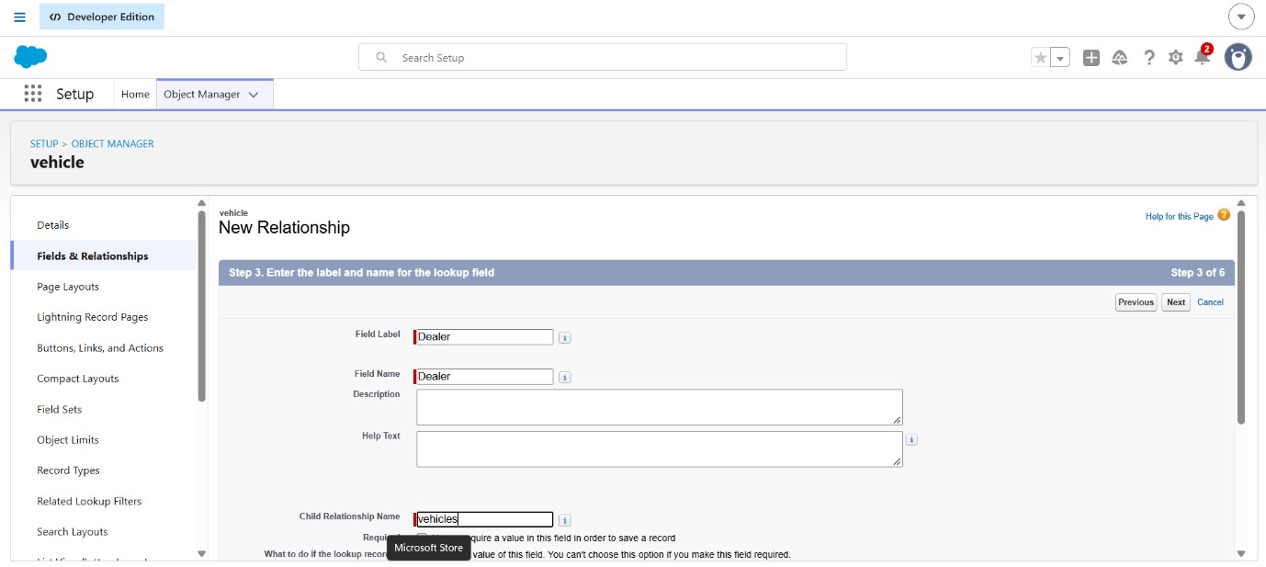

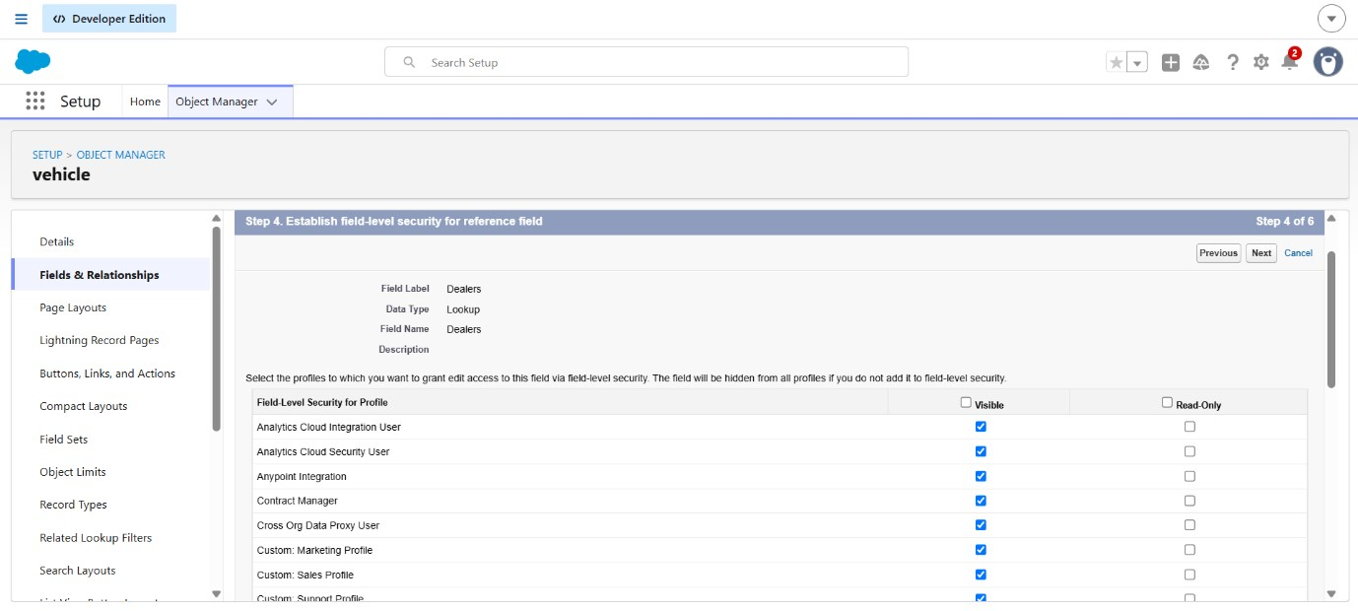

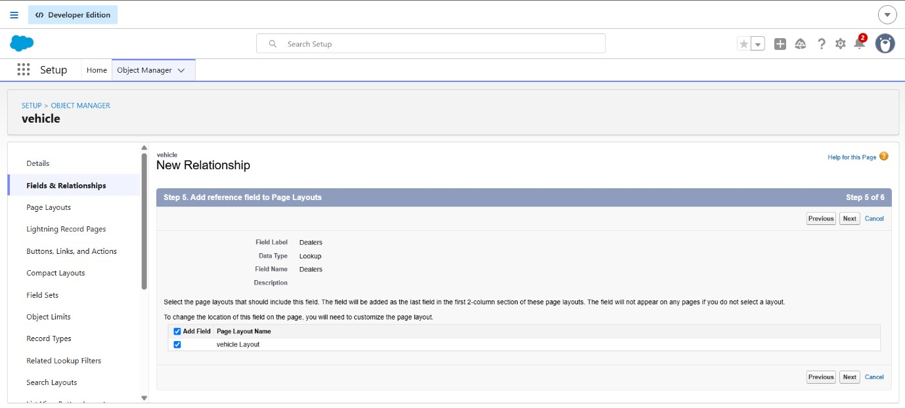

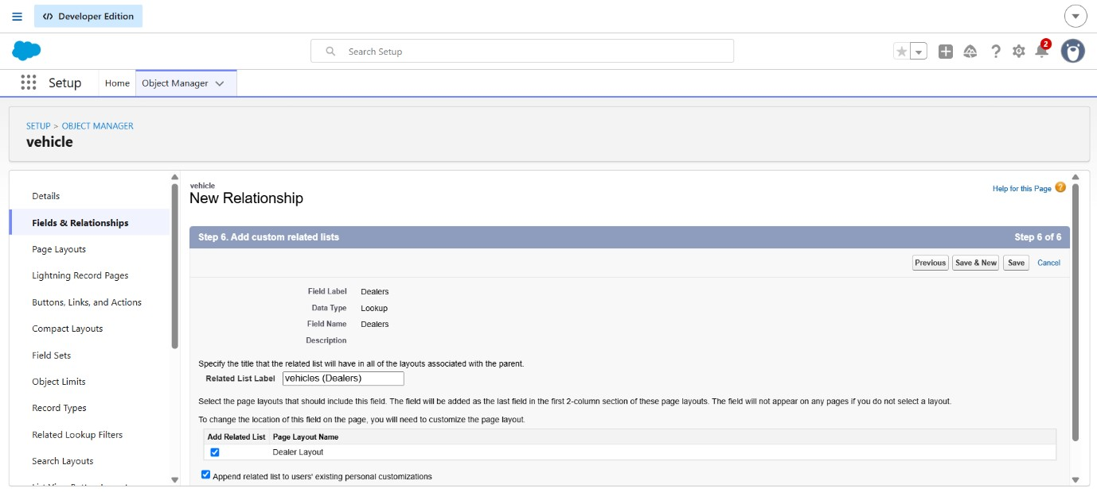
Mission 6:
Flow:1 Creating a record triggered flow to assign nearest dealer to the customer’s location:
A Record-Triggered Flow is created to automatically assign the nearest dealer to a customer when a new vehicle order is created. The flow retrieves the customer's location, finds the appropriate dealer, and updates the order with the selected dealer.
Step 1: Create a Record-Triggered Flow o Go to Setup. o Search for Flows in the Quick Find box.
- Click Flows. o Click New Flow. o Select Record-Triggered Flow. o Select the Vehicle Order object. o Choose A record is created as the trigger. o Select Optimize the Flow for: Actions and Related Records. o Click Done.
Step 2: Get Customer Information o Click the + icon below the Start element. o Select Get Records. o Enter the label as Get Customer Information. o Select the Vehicle Customer object. o Set the condition to find the customer related to the current order.
- Store the required customer details, especially the Customer Address/Location. o Click Done.
Step 3: Get Nearest Dealer o Click the + icon after Get Customer Information. o Select Get Records. o Enter the label as Get Nearest Dealer. o Select the Vehicle Dealer object. o Use the customer's location to identify the appropriate/nearest dealer. o Store the dealer record that matches the customer's location. o Click Done.
Step 4: Assign Dealer to Order o Click the + icon after Get Nearest Dealer.
- Select Update Records.
- Select Use the record that triggered the flow. o Set the Dealer field of the Vehicle Order to the dealer obtained from Get Nearest Dealer. o Click Done.
Step 5: Save and Activate o Click Save.
- Enter a suitable Flow Label, such as Assign Nearest Dealer to Order.
- Click Activate.

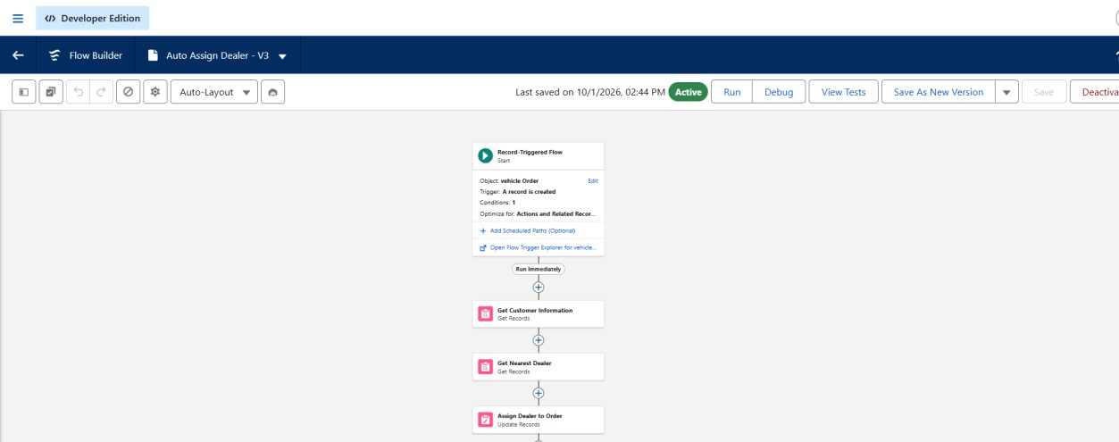

Flow:2 Creating record triggered flow to sen an email to the customer reminding about the test drive:
A Record-Triggered Flow is created to automatically send an email reminder to the customer before their scheduled test drive. This reduces manual work and helps customers remember their appointment.
Step 1: Create a Record-Triggered Flow o Go to Setup → Flows. o Click New Flow. o Select Record-Triggered Flow.
- Select the Vehicle Test Drive object. o Choose A record is created or updated.
- Set the entry condition:
Status = Scheduled o Select Actions and Related Records. o Click Done.
Step 2: Set Reminder Before Test Drive o Click the + icon below the Start element. o Select Get Records or configure a Scheduled Path depending on the required reminder timing.
- Create a scheduled path named Reminder Before Test Drive. o Set the path to run before the Test Drive Date. o Choose the required reminder time, such as 1 day before the test drive.

Step 3: Get Customer Information o Click + on the reminder path. o Select Get Records. o Enter the label as Get Customer Information. o Select the Vehicle Customer object.
- Use the customer lookup from the Test Drive record to find the related customer. o Store the customer's Name and Email. o Click Done.
Step 4: Send Test Drive Reminder o Click + after Get Customer Information. o Select Action. o Choose Send Email. o Enter the label as Send Test Drive Reminder. o Select the customer's email address. o Enter a suitable subject, such as:
Subject: Reminder: Your Test Drive Appointment o Add the email message with the test drive details. o Click Done.
Step 5: Save and Activate o Click Save.
- Enter the Flow Label as Test Drive Reminder.
- Click Activate.

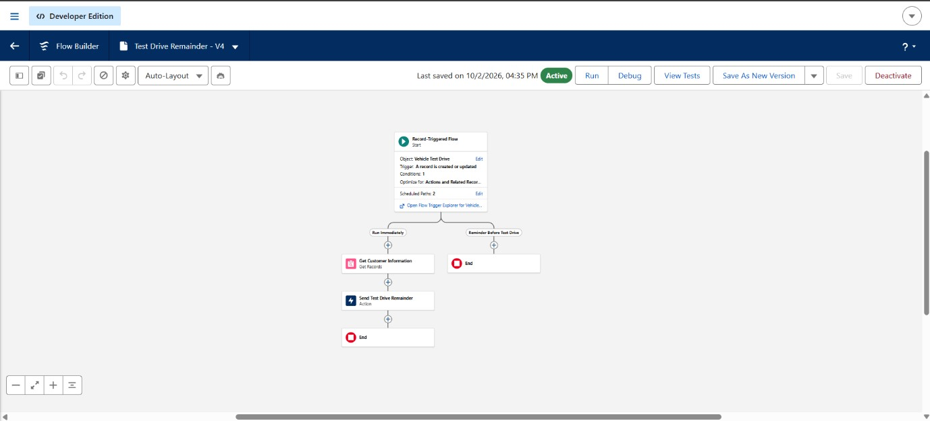
Test your Flow:

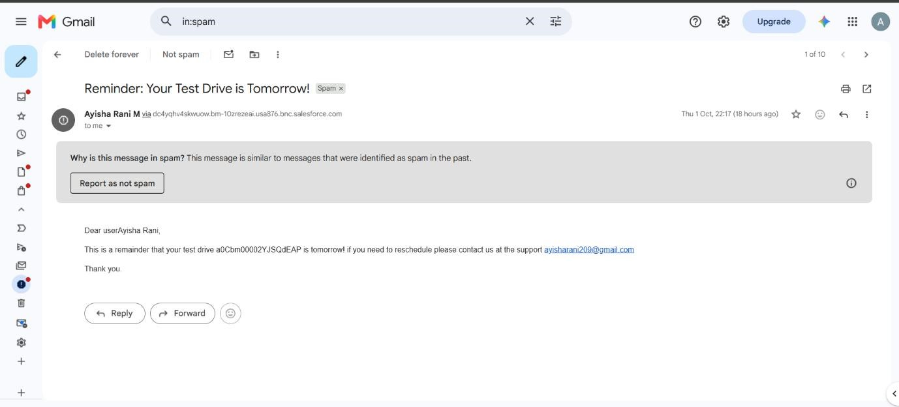

Mission 7:
Create and trigger batch job:
Step1:Open Developer console and create these process.

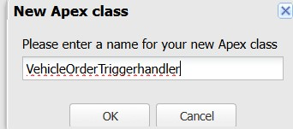

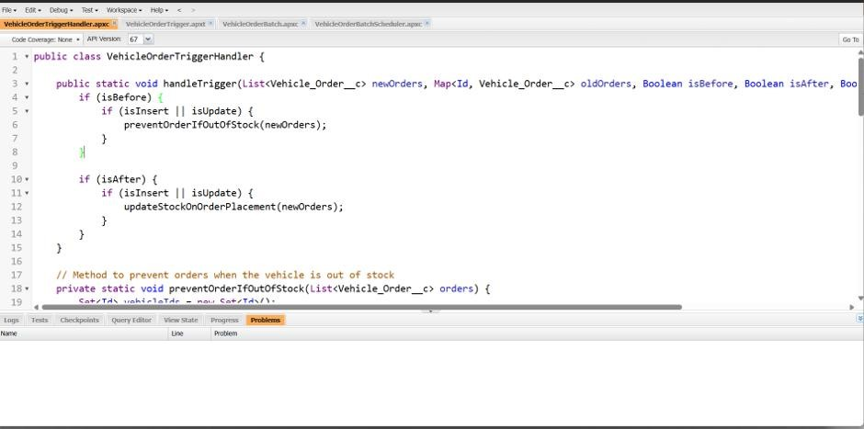

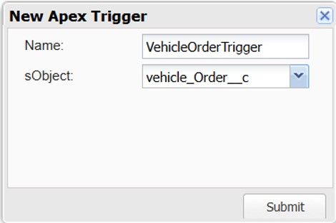

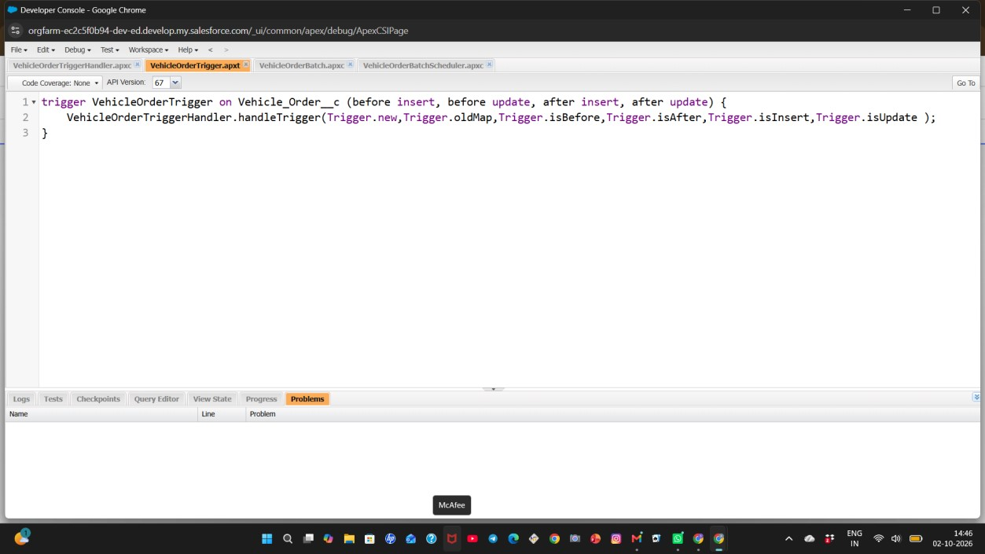

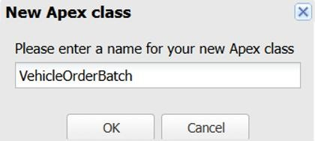

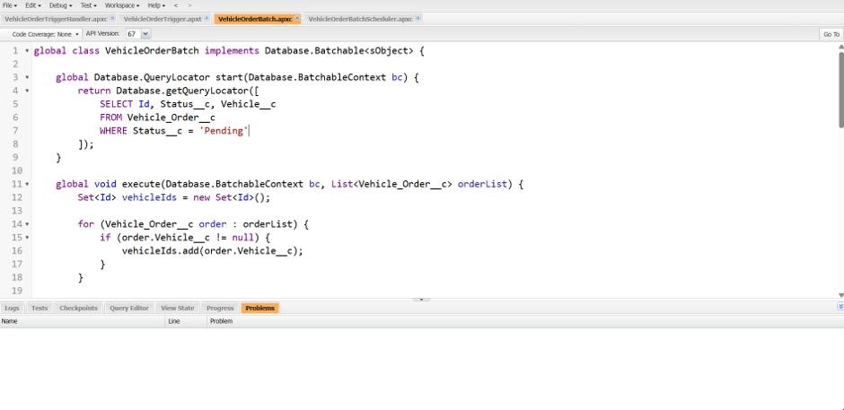

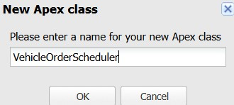

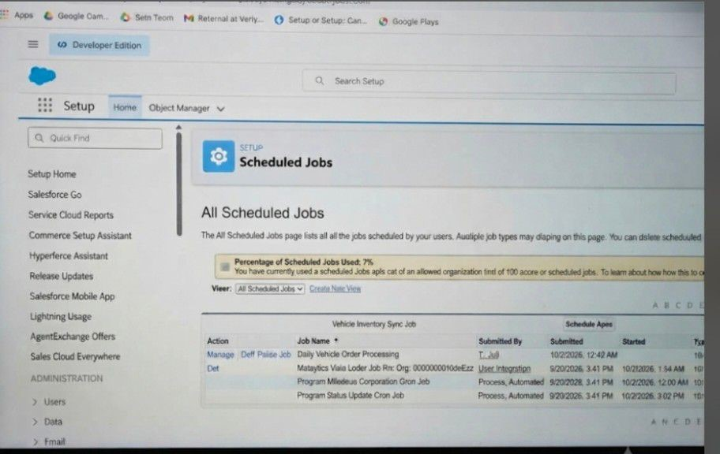
THANK YOU

